# End user documentation

# Vending machine

A vending machine is a self-service machine that provides items such as drinks and snack items after money has been inserted into the machine.

Vending machines are very convenient. With these machines, you do not have to go all the way to a store to get a snack, which saves a lot of time. They do not take up a lot of space which eliminates the cost of renting space.

Vending machines also offer the advantage of mobility. They can be moved to different places and still offer the same services in the same way without the need for specialized attention. They are available 24 hours throughout the year and can also offer a wide range of products.

Own vending machine offers the following:

* Chocolate
* Cola
* Orange
* Sweets

The user has the option to choose between any of the above mentioned. Once that is done, the machine will display the total amount to be paid. It will only accept: R5, R2, R1, c50, c20 and c10 coins. As the user inserts coins, the machine will display the balance due until the full amount has been inserted.

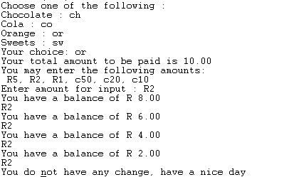

If the user pays more than the amount due, they are given back change. At the end of each purchase, a message is displayed.

